Answer the following questions in complete sentences. This section should be at least 2 pages, double spaced.
- What was the total amount of calories you were recommended to eat per day according to nutritiondata.com? Did you meet your estimated daily energy expenditure? If not, was it higher or lower? Explain.
- According to your recommendations from the nutritiondata.com website, did you meet your macronutrient (Carbs, Fat, and Protein Percentage Range) for each of the three days? Explain.
- Is this 7-day diary a good representation of your normal diet and eating habits? Why or why not?
- What were some of the challenges you faced when you were recording your diet? Name at least two.
- What are the social, economical, and cultural factors that influence your food choice? How did they influence you?
- What are your strengths of your food intake? Name at least two.
- What are specific areas for improvement in your diet? Name at least two.
- List 3 things you have learned from this project.

Christian Harvey

Diet Log Assessment

Course # and Section #

October 6, 2021

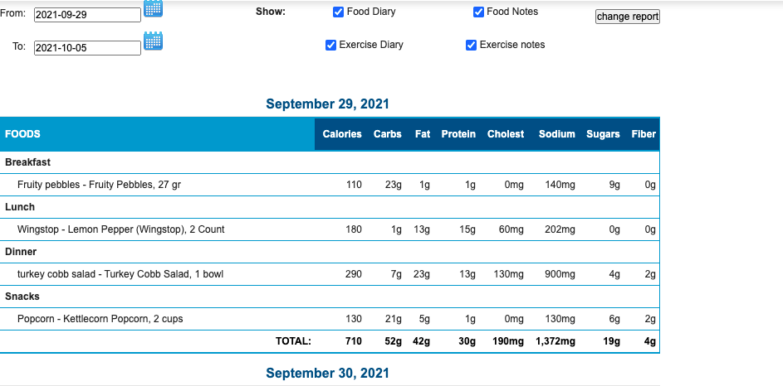

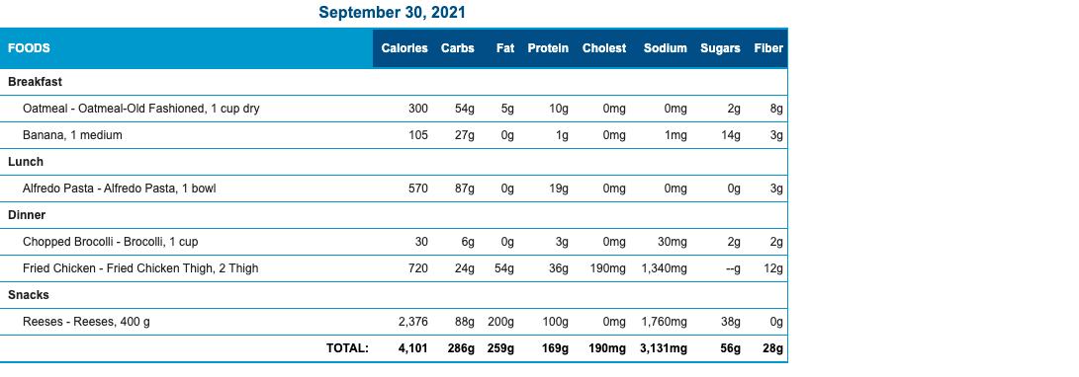

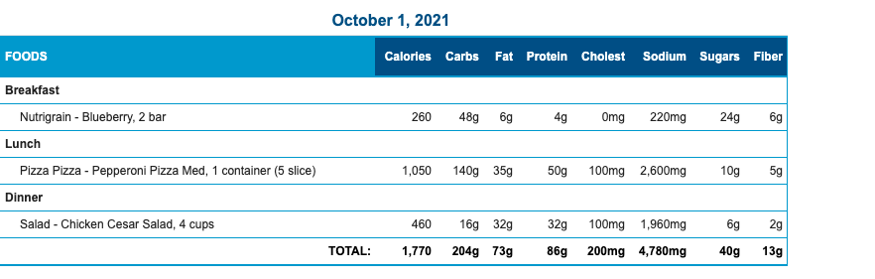
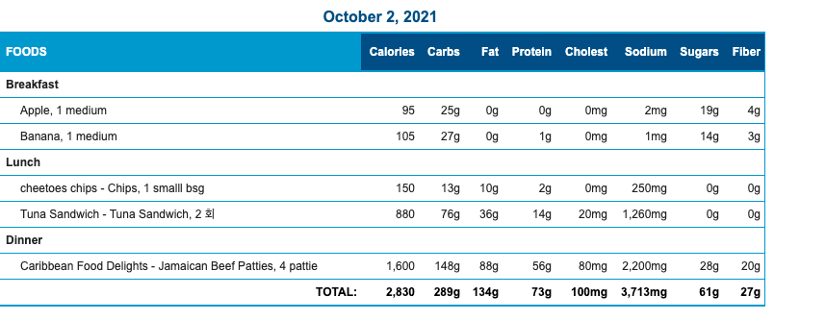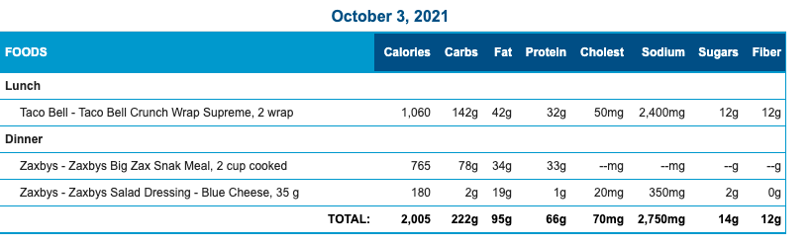

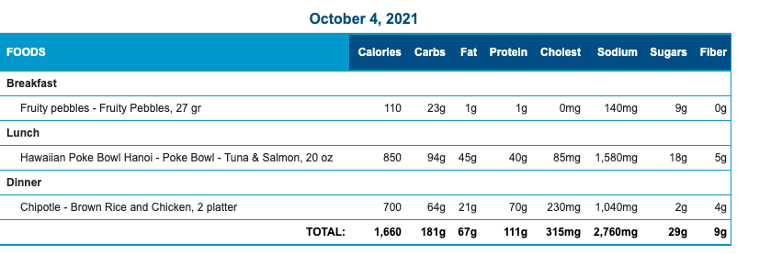
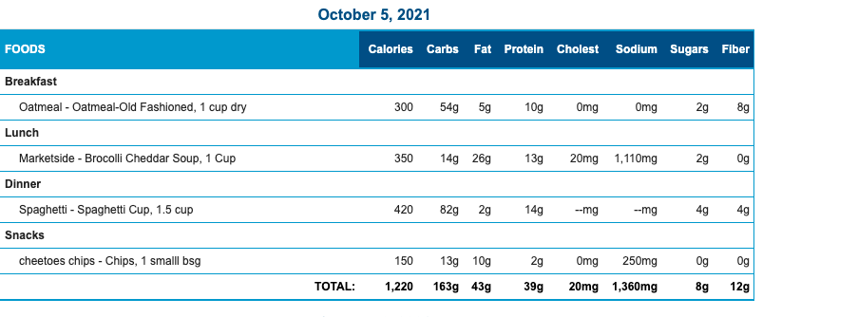

September 29, 2021

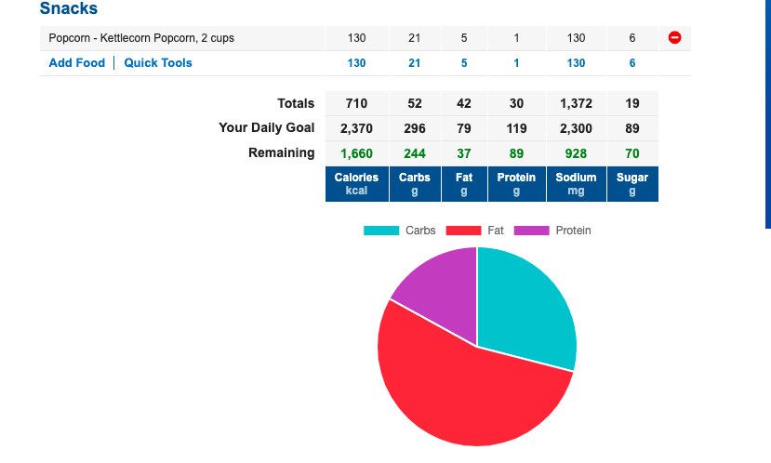

September 30
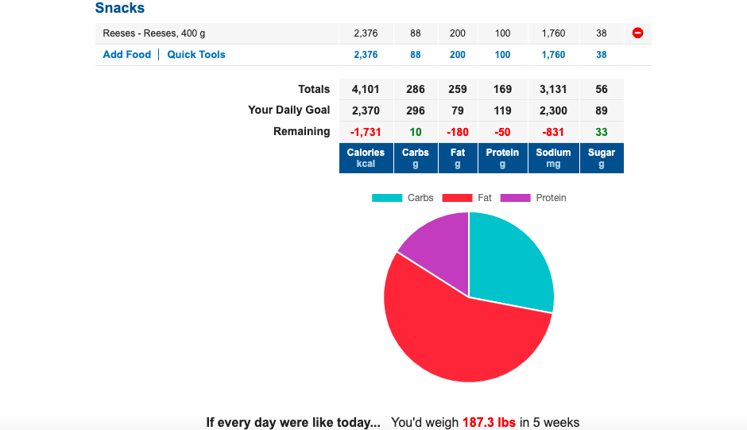

October 1, 2021

October 2, 2021
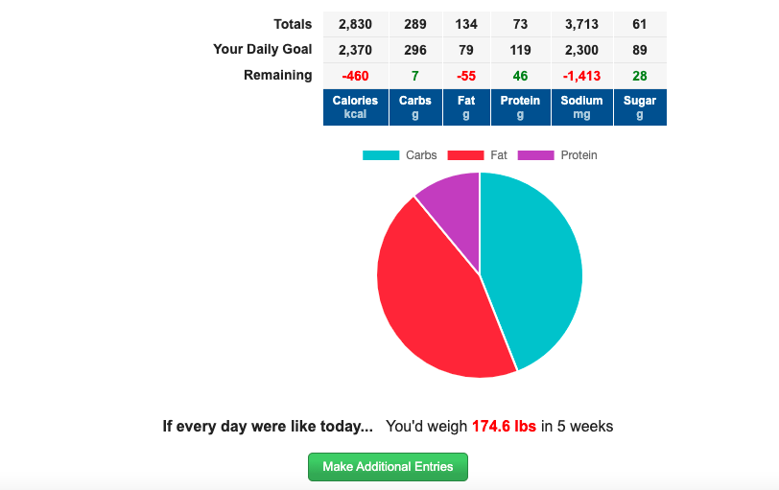

October 3, 2021

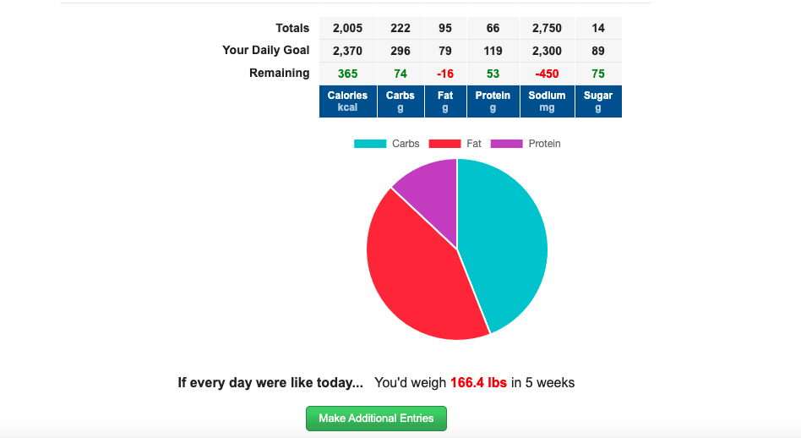

October 4, 2021
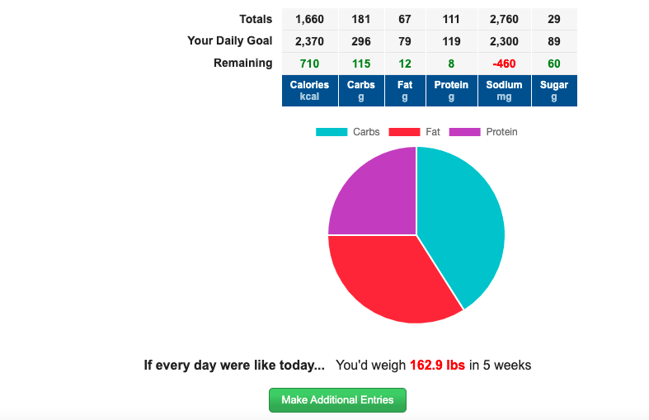

October 5, 2021

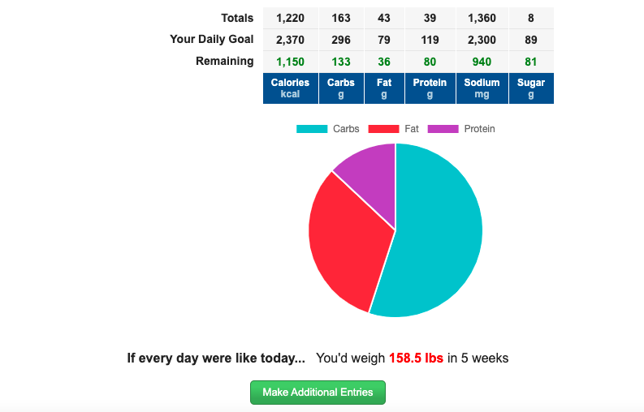

October 6, 2021
